**Project Report**

**FOR**

**Laptop Price Prediction**

**IN PARTIAL FULFILLMENT OF**

**MASTER OF COMPUTER APPLICATION**

**BY**

**Seat No :- 20055**

**SWANAND SANJAY DONGARE**

**Project Guide: - Dr. SUNIL KHILARI**

**MCA-FY SEM-1**

**2020-2022**

**SUBMITTED TO**

**SAVITRIBAI PHULE PUNE UNIVERSITY**



**SINHGAD INSTITUTE OF MANAGEMENT PUNE-411 041**

Date:-

**CERTIFICATE**

This is to certify that Mr. Swanand Sanjay Dongare has successfully / partially completed his/her project work entitled **“Laptop Price Prediction”** in partial fulfillment of MCA II SEM-III Industry Project for the year 2021-2022. He has worked under our guidance and direction.

**Prof. Dr. SUNIL KHILARI**  **Dr. Chandrani Singh**

**Project Guide Director SIOM - MCA**

**Examiner 1 Examiner 2**

**Date:**

**Place:**

Acknowledgement

A project report plays vital and important role as the practical counterpart in our curriculum. It gives us preview and chances to see what had to contain within practical world outside. During the project there were professor who helped me whole heartedly. I am thankful to all my faculty who helped me making this project up to mark and success. First I would like to express our indebtedness and heartfelt gratitude to our PRINCIPAL, and my project guide **Dr.SUNIL KHILARI SIR** for the relentless and painstaking efforts taken by them and their suggestions, scholar guidance and constant encouragement at every step of my project. I got to enhance both my practical and theoretical knowledge of system design under the project guides direction. I would like to take this opportunity to thank all my faculties for patience and encouragement during project work.

**Place:**-Pune

**Date:-**

**Mr. Swanand Dongare**

**MCA (II)**

**INDEX**

|  |  |  |
| --- | --- | --- |
| **Sr. No** | **Contents** | **Pg.no** |
| 1. | **Introduction** | 1 |
|  | 1.1 Problem Statement | 1 |
|  | 1.2 Motivation | 2 |
|  | 1.3 Objective | 2 |
| 2 | **Project Requirement Specification** | 3 |
|  | 2.1 Description | 3 |
|  | 2.1.1 Project Scope | 3 |
|  | 2.1.2 Software Resource | 4 |
|  | 2.1.3 Hardware Resource | 4 |
| 3 | **System Diagram** | 5 |
|  | 3.1 Data-Flow Diagram | 5 |
|  | 3.2 Use Case Diagram | 6 |
|  | 3.3 Use Case Diagram For Admin | 8 |
|  | 3.4 Activity Diagram | 9 |
|  | 3.5 System Design | 10 |
| 4 | **Implementation** | 11 |
| 5 | **Project Screen-Shots** | 13 |
|  | 5.1 Home Page | 13 |
|  | 5.2 Input data | 14 |
|  | 5.3 Result | 15 |
| 8 | **Conclusion And Future Scope** | 16 |
|  | 8.1 Conclusion | 16 |
|  | 8.2 Future Scope | 16 |
| 9 | Bibliographer | 17 |

**Introduction**

Artificial Intelligence is an integral part of all major e-commerce companies today. With the evolution of the information industry and extensive research in the field of AI in the past two decades, businesses have started to explore the ways to automate various activities using state of the art Machine Learning algorithms and Deep Neural Networks.

Predicting the price of a product is a tough challenge since very similar products having minute differences such as different brand names, additional specifications, quality, demand of the product, etc. can have very different prices. For example, one of these gaming laptop cost 70,000rs and the other cost Rs 130K. Can you guess which one’s which? Price prediction gets even more difficult when there is a huge range of products, which is common with most of the online shopping platforms.

Around 160 Million laptop sold every year so our target is to showcase the approx price for that particular specification of laptop and that is the reason why I have try to implement this to app help to people

The problem statement is that if any user wants to buy a laptop then our application should be compatible to provide a tentative price of laptop according to the user configurations.

**Problem Statement**

* When we go to buy laptop in any e-commerce site or in a shop we can see the huge price difference so that's why this project will to predict tentative price for that specification
* Predicting the price of the product is tough challenge since very similar product having minute difference such as different brand, different size many more so that's its very difficult to predict the exact price of laptop

**Motivation**

* Artificial Intelligence is an integral part of all major e-commerce companies today. With the evolution of the information industry and extensive research in the field of AI in the past two decades, businesses have started to explore the ways to automate various activities using state of the art Machine Learning algorithms
* In today’s digital world every-field accepting digitization for that everyone needs laptop or desktop so that’s why buying laptop according to over specification and in the actual price will be helpful for everyone

**Objectives**

* The main objective is to predict the actual price, Which is a classic categorical classification problem. It is needed to build a model that can find out the approx price of the product
* Around 160 Million laptop sold every year so our target is to showcase the approx price for that particular specification of laptop and that is the reason why I have try to implement this to app help to people

**Project Requirement Specifications**

**Description** -

* In Machine Learning based classification although there are so many algorithms are present but we try some different approach with better accuracy
* It will help to buy laptop in right price .
* Anyone Can easily find out the Tentative price for that Specification

**Project scope**:

A software requirements specification (SRS) is a document that is created when a detailed description of all aspects of the software to be built must be specified before the project is to commence. It is important to note that a formal SRS is not always written. In fact, there are many instances in which effort expended on a SRS might be better spent in other software engineering activities.

Overview of responsibilities of Developer: To have understanding of the problem statement.

To know what are the hardware and software requirements of proposed system.

To have understanding of proposed system.

To do planning various activities with the help of planner. Designing, programming

**Software Resource:**

Operating system : Windows 7 and above.

Coding Language :Python

IDE : Jupyter notebook, Visual Studio Code

**Hardware Resource:**

System : Intel I3 Processor and above.

Hard Disk : 200 GB.

Monitor : 15 VGA Color.

Ram : 4 GB.

**System Diagram**

1 Data Flow Diagram

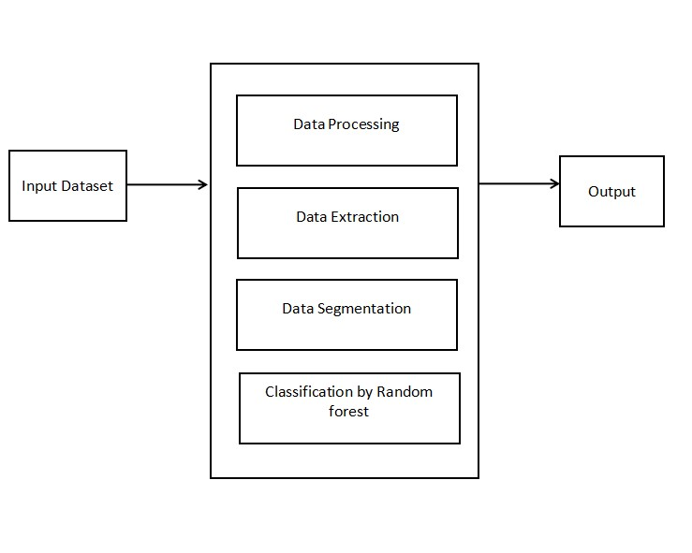

2 System Design

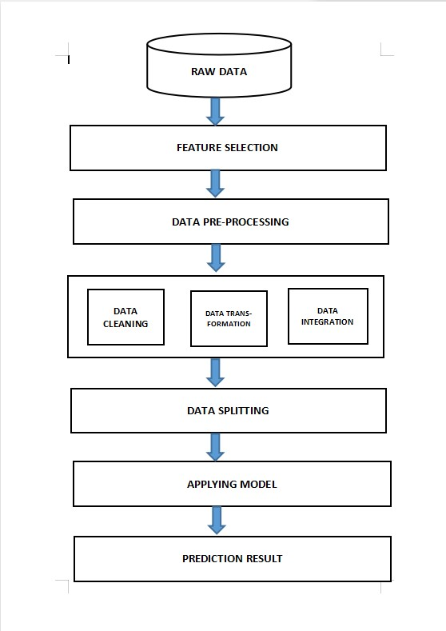

3.Use Case Diagram

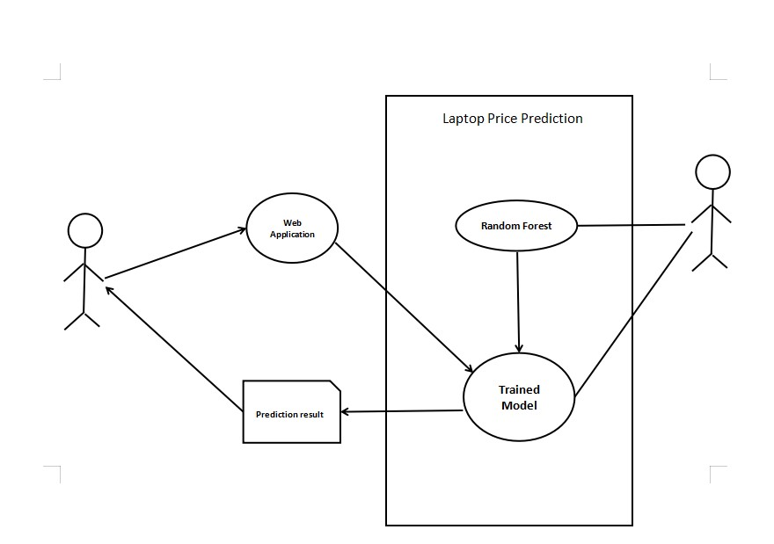

|  |  |
| --- | --- |
| Use case name | Laptop Price Prediction |
| Actor | User, Admin |
| Precondition | User must have filled all correct specification |
| Main flow | a)Fill all fields correctly  b)Data will go via pip-line  c) System apply machine learning modeling  d)Trained the model  e)Collect data  f)Predict Price |
| Output | Predict Price of Laptop |

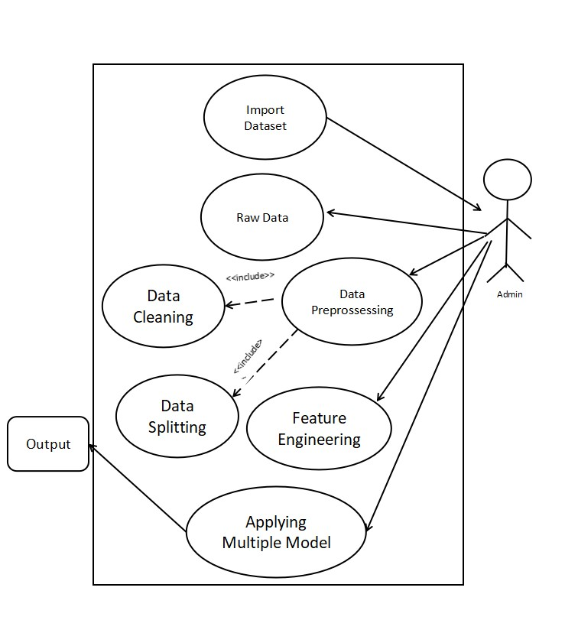

1. Use Case Diagram for Admin

|  |  |
| --- | --- |
| **Use case name** | **Use Case Admin** |
| **Actor** | **Admin** |
| **Description** | **The Use case describe the role of admin** |
| **Pre-Condition** | **User must be put correct specification** |
| **Main flow** | 1. **Import data** 2. **Raw Data** 3. **Data Processing** 4. **Data Cleaning** 5. **Feature Engineering** 6. **Data Splitting in Test Split and Train Split** 7. **Applying Model** 8. **Predict** |
| **Output** | **Predicted Successfully** |

4.Activity Diagram

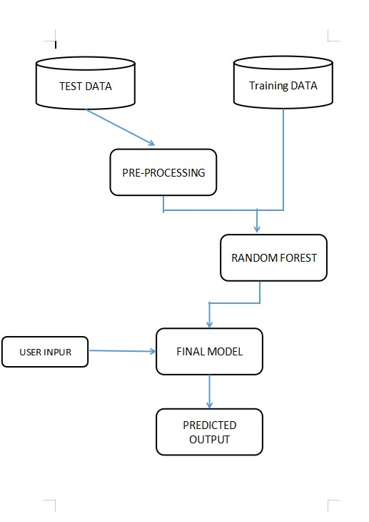

Implementation

**Raw Data**

In this work, the data is collected from the last two years with parameters such as (Company,Type-name,Inches,ScrennResolution,CPU,RAM,Memory,GPU,OS,Weight,Price)from keggle.com with the size of 177kb and 1300 Row

**Feature Selection**

As taking the raw data it consists of name, type, screen-resolution,

CPU etc., by taking all set of columns decreases the

accuracy of the program. So, without effecting the program

main things such as price are taken into consideration

so that the accuracy will not be effected.

**Data Pre-processing**

In this process all the missing cases are combined together

when and wherever possible. In this regression models the

data set is plot into a ratio of 80:20 where the 80% is trained

data set and remaining 20% is validation set. So by using

machine learning algorithm we perform the training for 80%of

the data set and then the 20% data is validated on the trained

data.

**Data Cleaning**-

In this method all the in accurate data is corrected for

all the record set. Data cleaning is a technique that can remove

unnecessary data such as null values null valued data causes

model may in accurate and miss leading of model prediction

Print df['p rice'].is nu ll

**Data Splitting**

It splits the data into the two parts. One part is for testing

and another for training data with ratio 80%:20% The word

“data” is plural, not singular.

**Applying Model**

Now the data is collected, and all the modeling techniques are

applied to the data. Random forest algorithm is applied to

the data-set where 80% data is trained and remaining 20%

data is tested for getting the resultant output.

**Prediction Result**

Now the data is tested for 20% and checked with the

trained data values. So by checking it can be able to predict accuracy of the program

**Random-Forest Algorithm**

The Random forest or Random Decision Forest is a supervised Machine learning algorithm used for classification, regression, and other tasks using decision trees. The Random forest classifier creates a set of decision trees from a randomly selected subset of the training set. It is basically a set of decision trees (DT) from a randomly selected subset of the training set and then It collects the votes from different decision trees to decide the final prediction.

**Project Screen-Shots**

Home Page

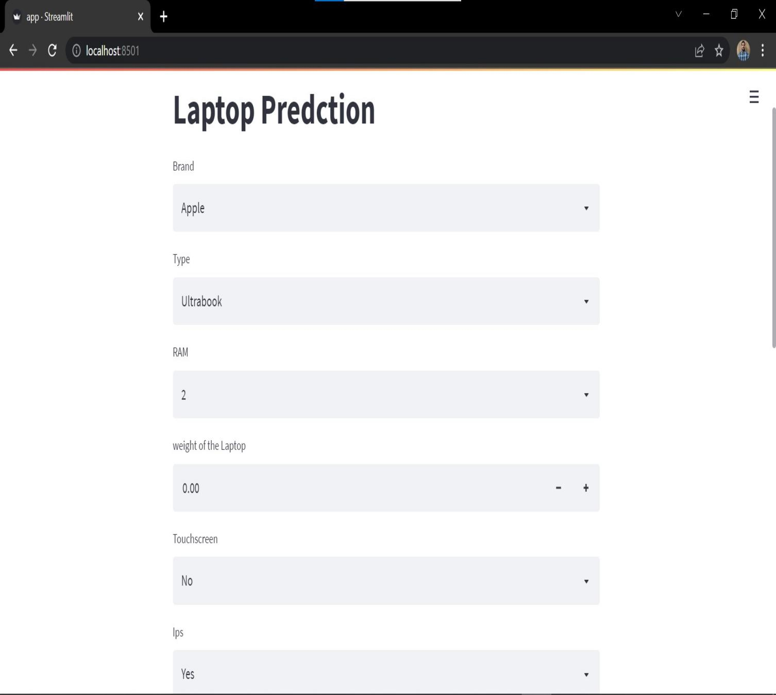

Input data

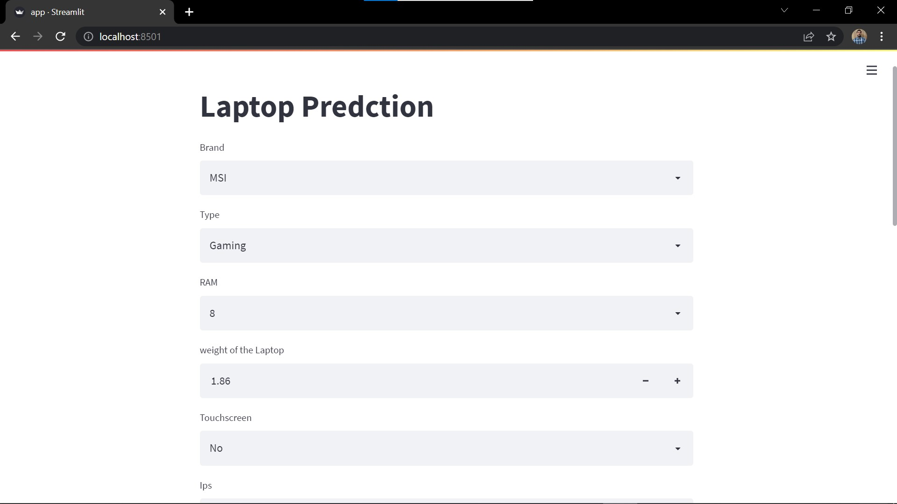

Result

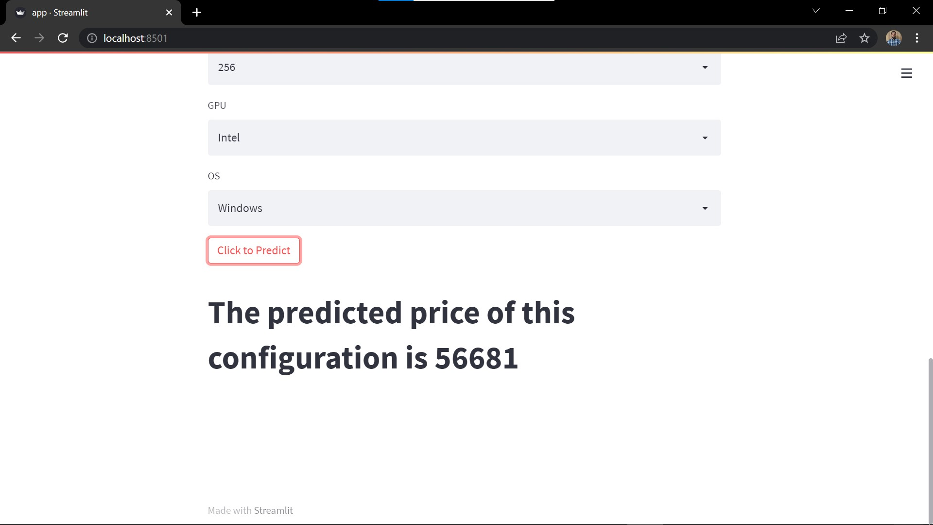

**Conclusion and Future Work**

Conclusion

The proposed Model predicts the price of a Laptop at a

given specific Price accurately. Random Forest algorithm is used to design this modal. This modal can be used by all the common people who are involved in buying laptop. The application is simple to be deployed in any environment.

As future work we can develop recommendation system accordingly predicted the price

Future Work

There are several research directions for future work. First, it might be interesting to think about other recent Machine learning models, like XGBoost any many other

learning, to create prediction models. The modal can be

extended for recommendation system accordingly predicted the price. But this model has disadvantages also because of the Laptop price also fluctuate because of the new technology and new updates this can cause our

Model Fails

**Bibliographer**

1. www.Google.com
2. www.Researchgate.net
3. www.Builtin.com
4. www.simplilearn.com